CYB 240 Module 4-1 Lab Worksheet

Andree Salvo
Southern New Hampshire University
CYB 240-13711
Instructor: Brian Remson

Lab: Remote and Local Exploitation
Prompt | Response
In the lab section “Privilege Escalation,” Step 8, insert your name at the command line below the output and include it in your screenshot. | 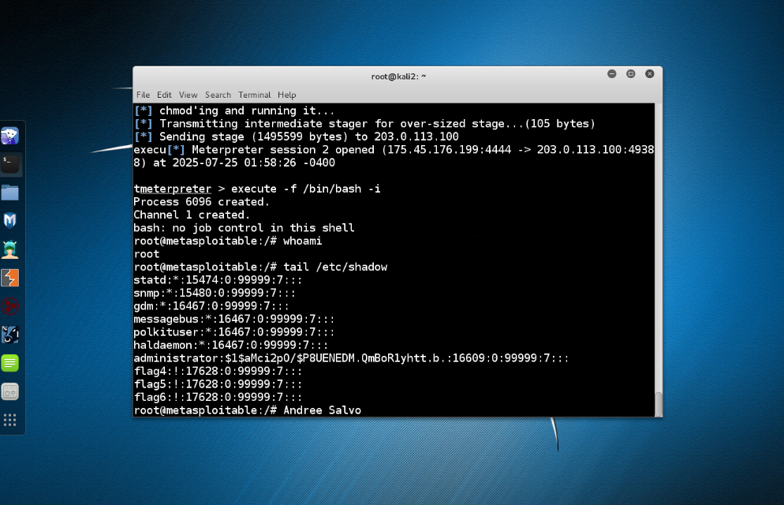
Privilege escalation is a topic that is recurring throughout cybersecurity. What does the term mean, and why should security specialists be concerned about it? | Privilege escalation occurs when an individual gains more access than they are authorized to have. It's a big concern because it can lead to full system control and significant damage.

Lab: HTMLi Vulnerability and Mitigation
Prompt | Response
In the lab section “Analysis of the Vulnerability,” Step 21, insert your name at the command line below the output and include it in your screenshot. | 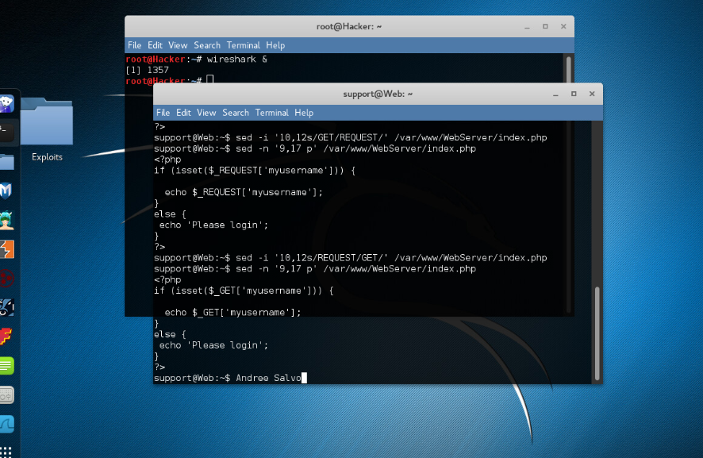
In the lab section “Verifying the Control Works,” take a screenshot after Step 4. | 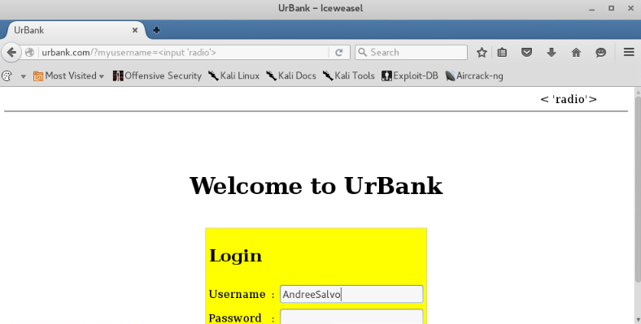  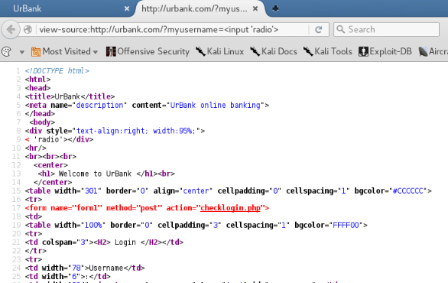
Like any other language, PHP eventually has deprecated commands. How can webpages or other web applications mitigate the risk of having deprecated code in the code base that can be exploited? | Web applications can mitigate risks from deprecated PHP code by keeping their codebases up to date, utilizing modern frameworks, and regularly scanning for outdated functions.

